
SHIRE HIGHLANDS EDUCATION DIVISION
2026 MALAWI SCHOOL CERTIFICATE OF EDUCATION MOCK
EXAMINATION

TECHNICAL DRAWING
PROVISIONAL MARKING KEY

PAPER II
(100 marks)
ORTHOGRAPHIC DRAWING
(ENGINEERING DRAWING)
Instructions

SECTION A (15 marks)
- Draw neat free hand sketches to show the following:

- Internal vee thread (3 marks)

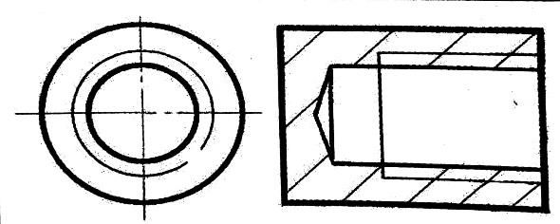

- Wing nut (3 marks)

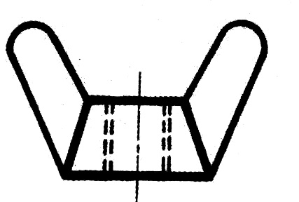

- Split pin (3 marks)

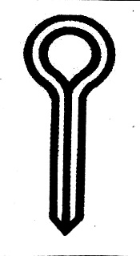

- Double headed feather key (3 marks)
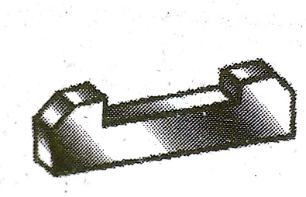

- lug (3 marks)

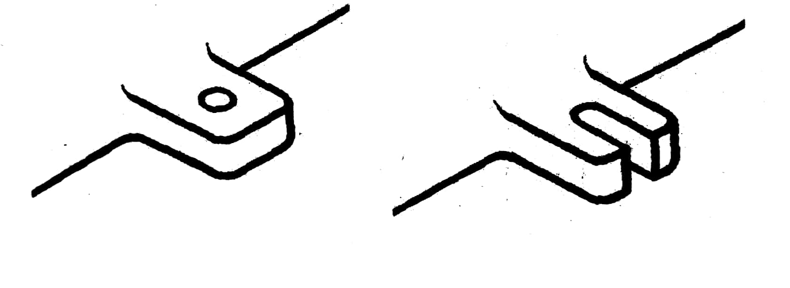

Section B (85 marks)
- The drawing on page 3 shows details of a SWIVEL MACHINE drawn in first angle orthographic projection.
With the parts correctly assembled, draw full size, in either first angle or third angle orthographic projection the following views:
- A sectional front elevation on the cutting line P-P (40 marks)
- Plan.
(Hidden details are to be shown on the plan only) (15 marks)
- An end view (18 marks)
- Insert the following dimensions (i) the overall height (ii) overall length (iii) any diameter (6 marks)

- In a title block 110m x 40mm high and then print:

(i) the title SWIVEL MACHINE in letters 6mm high
(ii) the scale used in letters 4mm high
ii) indicate, with an appropriate symbol, the type of projection used. (6 marks)
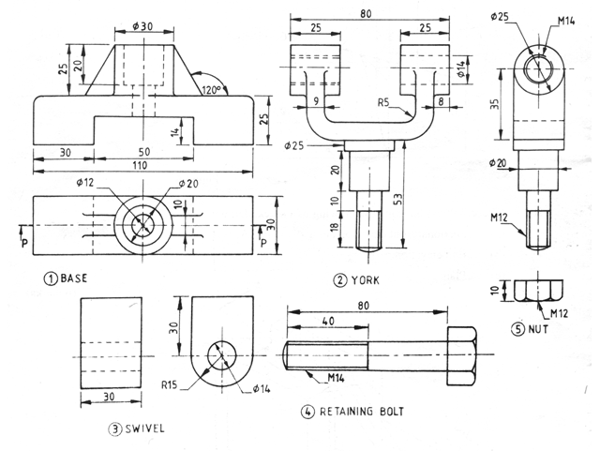
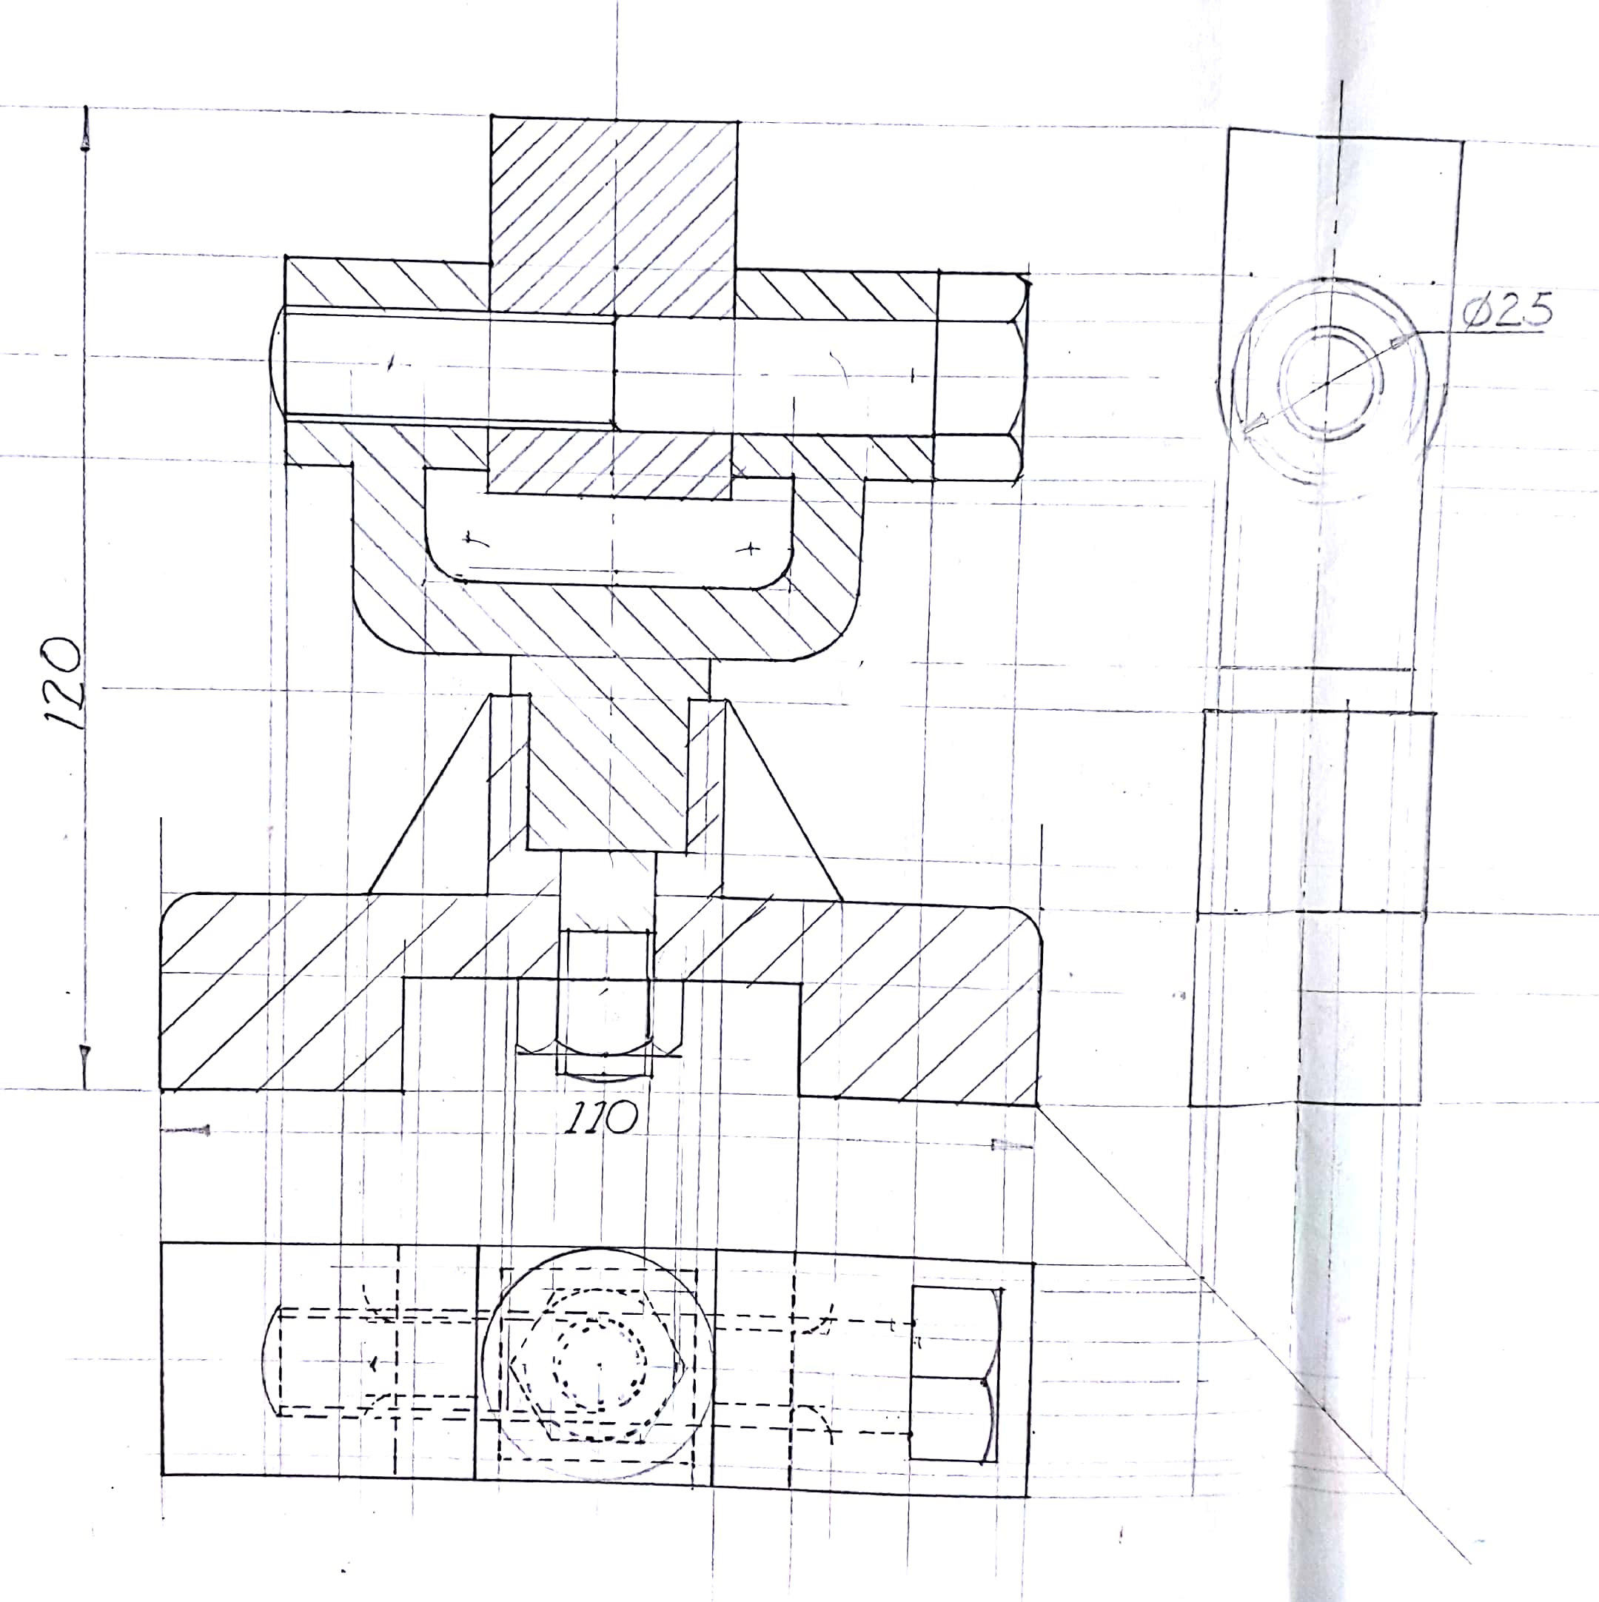
SECTIONAL FRONT ELEVATION
Centre lines……………………………………..2
Base…………………………………………….4
York ……………………………………………5
Nut………………………………………………4
Swivel……………………………………………3
Retaining bolt…………………………………….5
Correct hatching………………………………….9
Web drawn at 120⁰……………………………….2
Outline…………………………………………….3
Quality and accuracy………………………………3
TOTAL………………………………………..40 marks

PLAN
Swivel…………………………………………….3
Bolt………………………………………………..4
York………………………………………………..2
Nut………………………………………………….3
Web…………………………………………………2
Hidden details……………………………………….2
Outline……………………………………………….2
Quality and accuracy…………………………………2
TOTAL……………………………………………..20 MARKS

END ELEVATION
Base……………………………………………3
Swivel………………………………………….2
Bolt…………………………………………….2
Web…………………………………………….2
York…………………………………………….2
Quality and accuracy……………………………2
TOTAL………………………………………….13 MARKS
Overall height……………………………….2
Overall length………………………………..2
Any diameter…………………………………2
TOTAL……………………………………….6 MARKS
Tiltle block…………………………………….1
Scale…………………………………………….1
Printing………………………………………….2
Symbol…………………………………………2
TOTAL………………………………………..6 MARKS
END OF MARKING KEY

